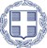
Consulate General of Greece in Istanbul

The Consul General of Greece in Istanbul Mr Evangelos Sekeris & the Head of the Economic and Commercial section Mr Doukas Marinopoulos have the pleasure to invite you to a business meeting event organized by the Economic and Commercial section of the Consulate General concerning the presentation of :

“Hellenic Maritime Equipment Manufacturers – Cooperation with Turkish Shipyards & Shipping companies”

The event will take place on Thursday November 23rd at 11.00 am at Sismanoglio Megaro (Istiklal caddesi 60)

Business meetings can be arranged after the presentation upon to your request

We send you attached the event’s program & the Greek companies profile & look forward to receiving your kind reply of your participation to the presentation & the business meetings you will request

RSVP for your participation until Wednesday November 15th at 212 2927118 or by email ecocom-istanbul@mfa.gr

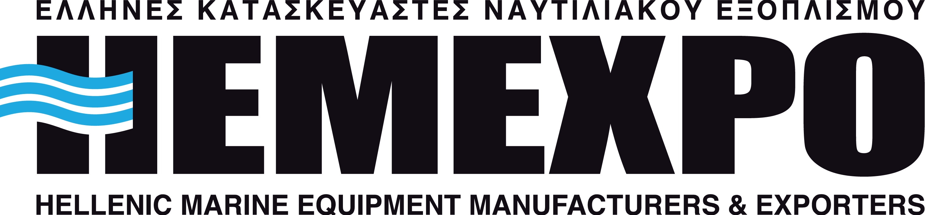

Program

10.00 – 10.30 : Registration - Coffee

10.30 – 10.45 : Welcome speeches by Consul General & Hellenic Maritime Equipment Manufacturers Association

10.45 – 11.45 : Presentation of Greek Manufacturing companies

11.45 - 13.45 : Scheduled Business meetings

13.45 – 14.15 : Light Buffet lunch

Names of the Greek companies you are interested to meet

1
2
3
4
5

RSVP for your participation until Wednesday November 15th at 212 2927118 or by email ecocom-istanbul@mfa.gr

